# CS 340 README Project 2

## About the Project/Project Title

Grazioso Salvage Search and Rescue Dog Finder. A web application designed to locate dogs around Austin Texas that match a specific profile to potentially become future search and rescue animals.

## Motivation

Grazioso Salvare is an international rescue-animal training company that identifies dogs in shelters that could potentially make good candidates for search and rescue training. Grazioso has reached an agreement with several non-profit animal shelters to help their mission in finding animals that fit their criteria of search and rescue dogs and now provide the company with a full list of the animals currently in their shelters. The company is seeking a software application that can work with the existing data from animal shelters to help identify and categorize available dogs. Global Rain has been contracted for a full stacks development of this application including the database and a client-facing web application dashboard through which the users at Grazioso Salvare will access the database.

## Tools Used

***MongoDB-*** MongoDB is a popular, open-sourced database management system. This database stores data in a flexible, JSON-like document within collections making it well-suited for storing and managing unstructured and evolving data. Considering that the data provided from the animal shelter will be unsorted and constantly changing, MongoDB is the best option for storing this data. MongoDB also has a Python driver which allows the capability to produce an MVC pattern application by using Python as the development language.

***Dash Framework-*** Dash is an open-sourced Python framework used for building analytical web applications. It is a library that simplifies the development of data-driven applications. Dash helps to build interactive web dashboards that look good and are very fast to create. This will be used as the visual interface for the information pulled from the queries

***Python-*** Python is a high-level, general purpose programming language that is known for its versatility and readability. It is widely used in web development and data science/analytics while being relatively user friendly. Python comes with an expansive library and prebuilt modules making it the ideal language for developers.

***Plotly-*** Plotly is one of the prebuilt data visualization libraries within Python that is known for being open-sourced and having interactive web-based visualizations. It is used for creating a wide variety of charts including 3D graphs, statistical charts and scientific graphs. This library will be the module that is used to make visuals in web applications.

***Python CRUD Library-*** The CRUD Library is a module created by me that connects the data stored within the MongoDB and prepares it to be used in the web application. CRUD stands for Create, Read, Update and Delete in reference to how the data can be manipulated by the user through the animal shelter and Grazioso.

**Steps Taken**

1. Set up MongoDB by importing the CSV file given from the animal shelter and create an account user through mongosh.
2. Create the CRUD library that imports the data from MongoDB. The library should include the 4 methods of create, read, update and delete.
3. Build the dashboard layout by creating interactive filters, data tables and charts.
4. Implements callbacks of interactivity to updating charts and data tables based on the filter selections.
5. Testing and debugging to ensure that all components of the application work properly.

## Functionality

The functionality of this application is to create an easy to navigate dashboard for users to search for and view for dogs in Austins that meet the requirements of becoming a search and rescue trainee. Upon loading the application, the user will be met with the main dashboard that shows the Grazioso Icon which links back to SNHU page along with the name of this course as well as my name as author. A list of buttons indicating the types of rescues will be underneath that including: Water rescue, Mountain/Wilderness, Disaster and Reset that have the potential to be clicked on by the user to narrow down types of dogs. A data chart of dogs provided by the animal shelter will be shown. Underneath the chart will be a geo map showing locations of the animal selected and a pie chart indicating the preferred animal by breed.

**Challenges and Solutions**

***Authentication Errors:*** Had to adjust the initialization parameters in the CRUD module to properly import the data

***Interactive Filtering:*** Debugged issues with filter options not updating the data correctly by refining the MonoDB queries.

***Formatting Error:*** Ran into issues with formatting in Python and was fixed through trial and error

### Code Example

The code includes an Animal Shelter Class that initializes the Mongo Client and connects the specific variables from the ACC database in MongoDB. This uses the aac database, the animal collection and the aac user.

Methods are added to be able to create, read, update and delete new animal information that is inputted into the list.

The CRUD module is imported to Project file by authenticating user and password.

The dashboard is created by adding the logo, rescue type buttons, data table, pie chart and geo location map.

Callbacks to filter interactive data, display breed on quantity represented, highlight a cell and update geolocation map for the selected data entry.

### Screenshots

**Import CSV:**

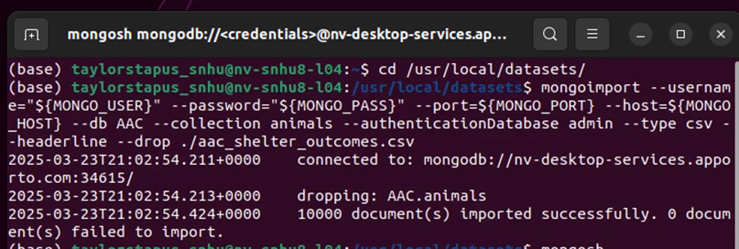

**Create aacuser:**

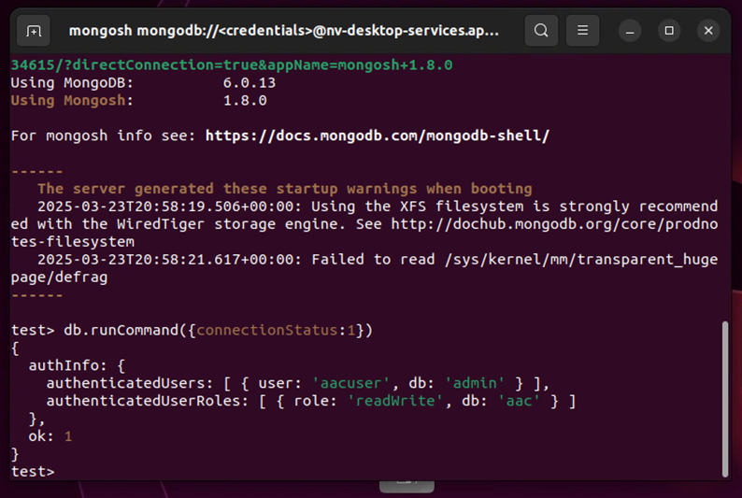

**AnimalShelter Class:**

**CRUD Method:**

**Accessing CRUD module in the Dashboard**

**Dashboard Layout and View**

**Callbacks**

*.*

## Contact

Your name: Taylor Stapus